POC Success Story

Project Title
Self-Hosted Marketing Automation Engine: Mautic v5 Integration with Custom Lead Capture and Analytics Dashboard

The Problem
Modern marketing operations rely heavily on SaaS automation platforms (e.g., HubSpot, Mailchimp, Marketo). However, enterprise businesses face three critical challenges with these platforms:
- High Recurring Costs: Subscriptions scale exponentially with database size (number of contacts).
- Data Ownership & Privacy: Sending sensitive customer information to third-party servers raises compliance risks under GDPR/CCPA regulations.
- Integration Friction: Seamlessly embedding capture forms into custom brand touchpoints while maintaining high-performance analytics dashboards can be complex.

Our Solution
We built a fully containerized, self-hosted marketing automation ecosystem using Mautic v5 (running via Docker) integrated with a modern, customized customer landing page and campaign analytics dashboard mockup.
The system implements the following automated workflow:
- Lead Capture: Visitors enter details via a responsive, custom-styled landing page.
- Database Synced Ingestion: Inputs are sent directly to the Mautic backend via secure API/JS scripts, creating contacts in real-time.
- Smart Segmentation: Leads are instantly sorted into target segments (e.g., Demo Subscribers).
- Triggered Campaigns: The contact instantly enters a drip campaign sequence (Demo Email Campaign) that triggers automated welcome emails.
- Analytics Review: Marketers monitor progress using a dark-themed analytics dashboard mockup showing KPIs, engagement charts, and device metrics.

Solution Architecture
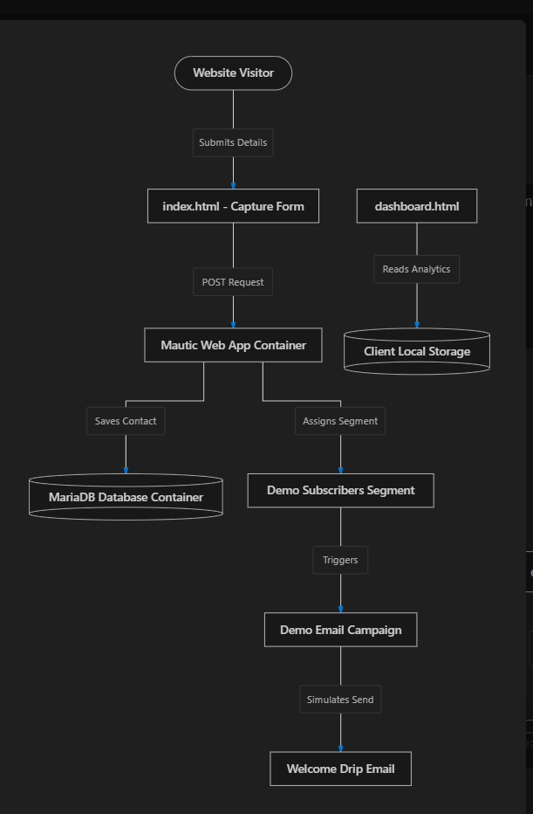

Deliverables
- docker-compose.yml: Service orchestration config with healthchecks, persistent volumes, and custom Apache docroot configs.
- index.html: Landing page featuring the live-connected Mautic signup form.
- dashboard.html: Custom dark-mode analytics dashboard showing key marketing metrics.
- style.css: Design token system for the landing page and dashboard mockup.
- app.js: Client-side validation, chart rendering, and local-storage logic.
- README.md: Comprehensive setup and operational documentation.

Tech Stack
- Containerization: Docker, Docker Compose
- Marketing Backend: Mautic v5, PHP 8.2, Apache 2.4
- Database: MariaDB 11 (Relational Database)
- Frontend Web: HTML5, CSS3 (Vanilla design token system), JavaScript (ES6, local-storage & DOM rendering)
- Server Runtime: Python (for local development server hosting)

Business Impact
- Zero Licensing Fees: By replacing commercial platforms with a self-hosted Mautic setup, companies can eliminate subscription fees, resulting in significant savings.
- 100% Data Sovereignty: Patient, financial, or consumer data remains fully inside the company's private cloud/hosting environment, making GDPR, HIPAA, and CCPA compliance simple.
- Open-Source Customizability: Marketers and developers can build custom integrations, plugins, and workflows without closed-source platform limitations.

Project Snapshots (Minimum 5 Pictures)
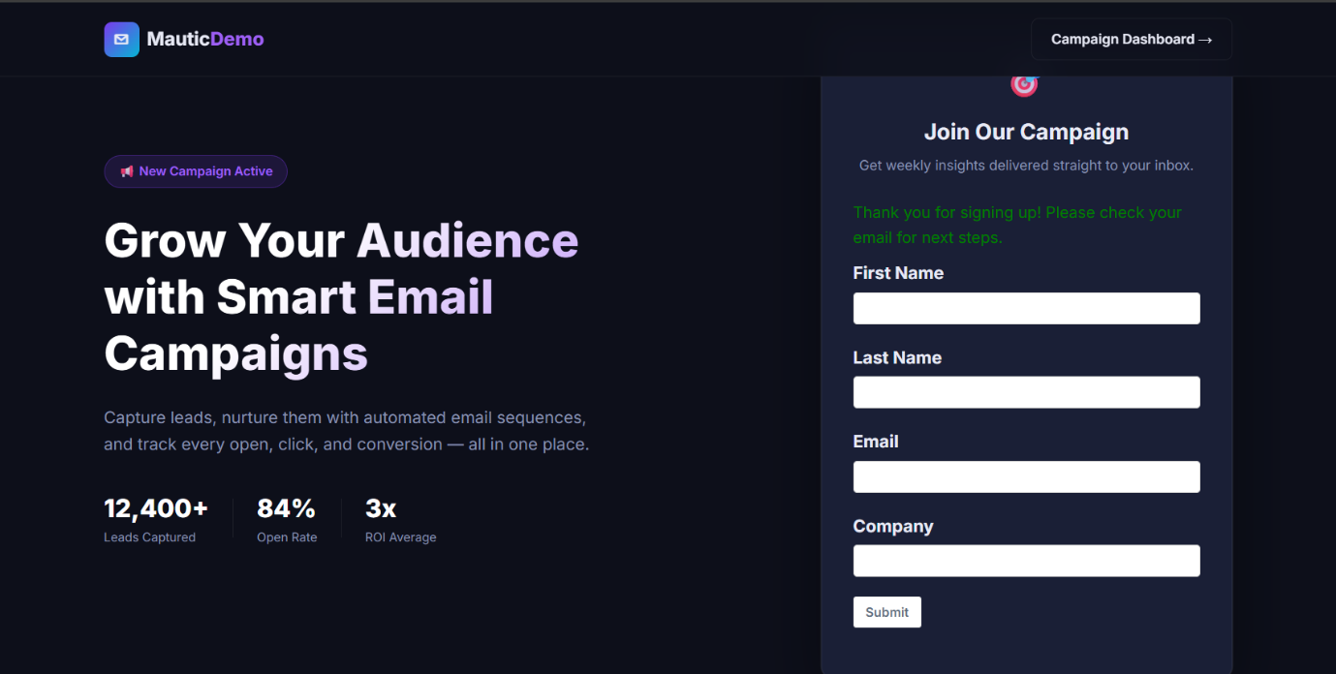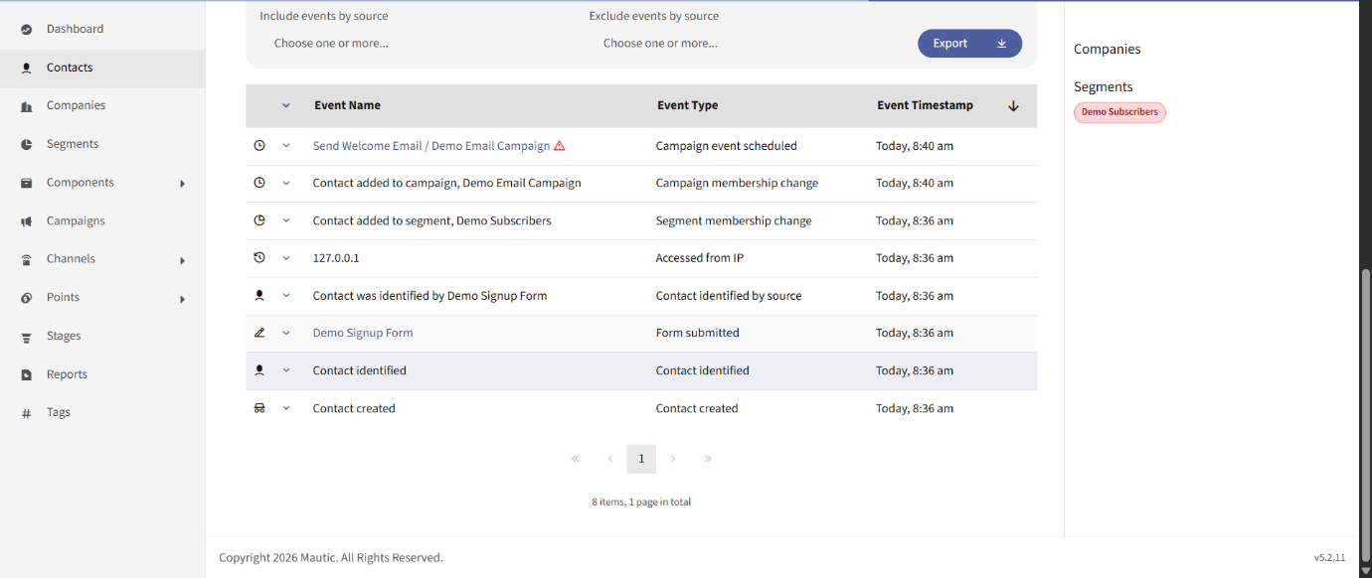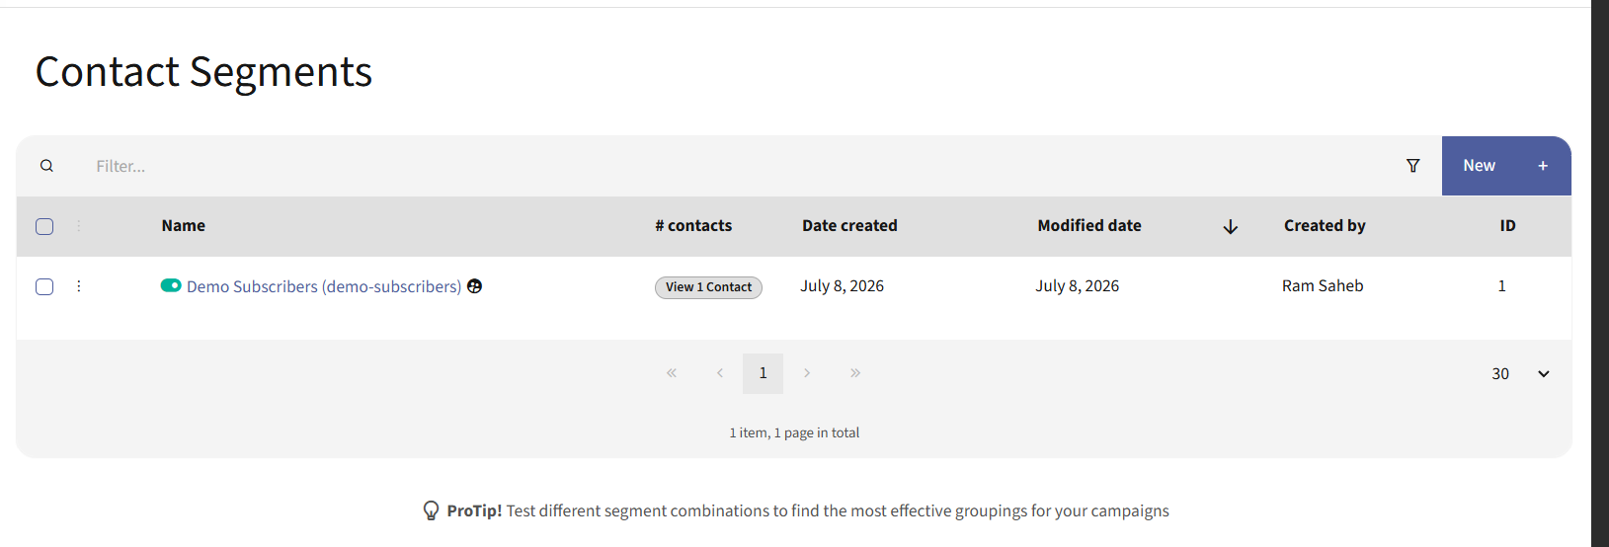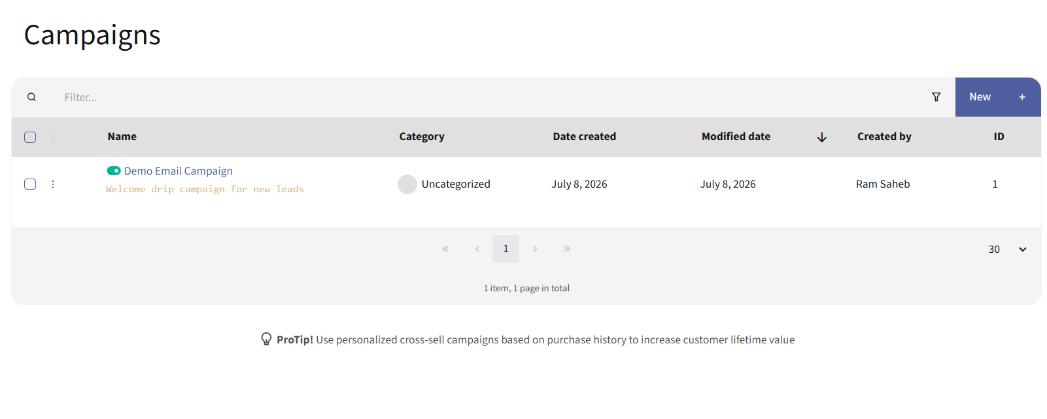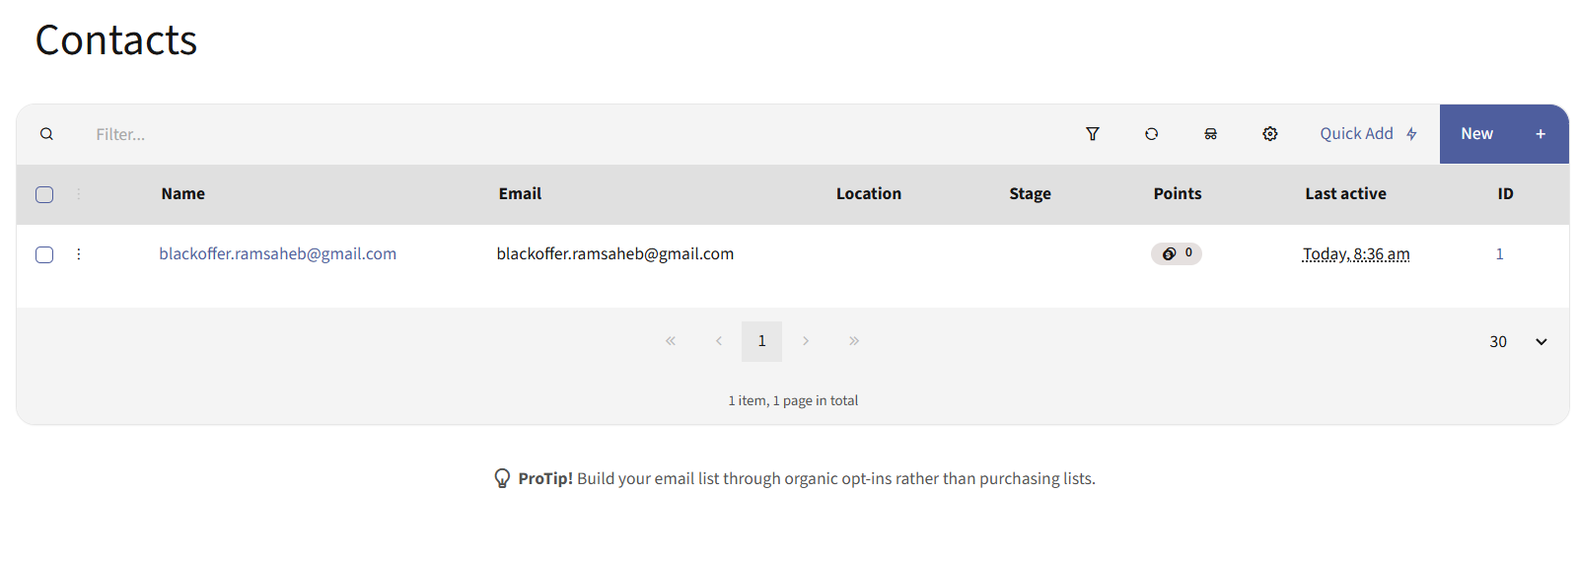

Project URL
https://github.com/blackoffer-ramsaheb/mautic-demo

Project Video
https://drive.google.com/file/d/15A1xSmrqKdbPWcwb_JV8rEO0mucxiBLO/view?usp=sharing

